Q: Which of the following statement is incorrect about using interactivity in building vis tools?

A) Interactivity is crucial to handling complexity.

B) Interactivity supports multiple queries

C) Interactivity prevents showing everything at once

D) Interactivity presents different ways of representing and summarizing the data

E) Interactivity can always increase efficiency

Q: Please select all the channels used for visualising data attribute values in the visualisation below.

(+1 mark per correct channel identified, -1 mark per incorrect channel selected).

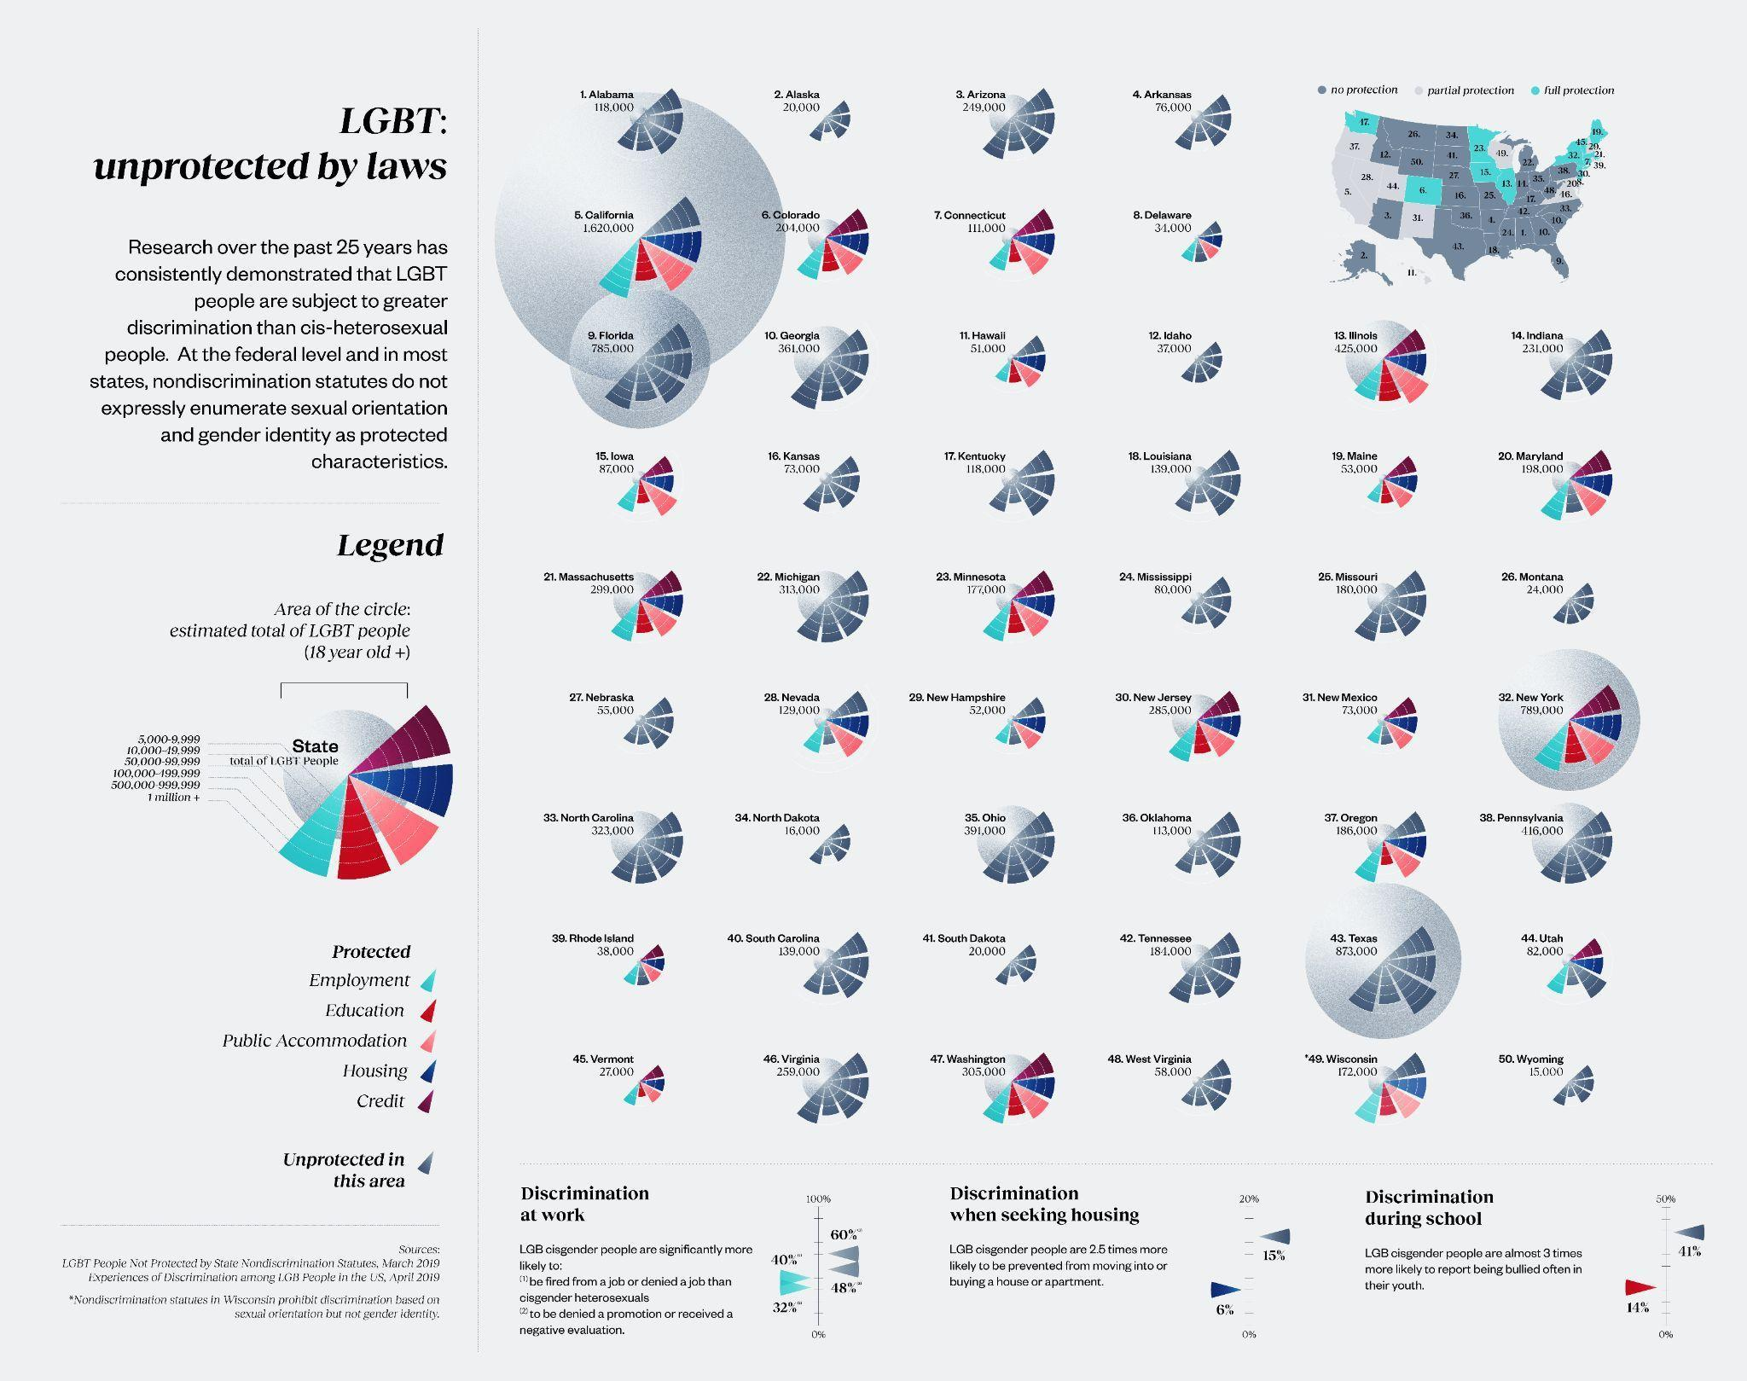A) Length

B) Angle

C) Position

D) Colour hue

E) Colour saturation

F) Texture

Figure 1. Stacked bar chart

Figure 2. Population pyramid

Question: How many attribute types (categorical, ordinal, or quantitative) are used in the stacked bar chart (Figure 1)?

1. 1
2. 2
3. 3
4. 4

Question: Select all the reasonable tasks (Why part) supported by the population pyramid (Figure 2) based on Munzner’s “what? why? how?” framework.

*Note: Please select all correct answers. Incorrect choices will be penalised.*

1. the distribution of the population separated by gender and age bin
2. the comparison of the population between different age bins
3. the comparison of the population between gender
4. the identification of the age bin which has max/min population for each gender

Question: Select all the visual marks and channels used in the stacked bar chart (Figure 1).

*Note: Please select all correct answers. Incorrect choices will be penalised.*

1. point
2. line
3. area (mark)
4. colour hue
5. colour luminance
6. position
7. 1D size
8. 2D size
9. shape

Question: What is the advantage of the population pyramid compared to the stacked bar chart?

1. it is more effective to compare the male or female populations across different age bins.
2. it saves more display space
3. it is more effective to compare the total population of male+female across different age bins
4. it is more effective to identify the individual population for each different age bin

Question: What is the advantage of the stacked bar chart compared to the population pyramid?

1. it is more effective to compare the male or female populations across different age bins.
2. it saves more display space
3. it is more effective to compare the total population of male+female across different age bins
4. it is more effective to identify the individual population for each different age bin

**New Questions 21-25 or another set of questions for question bank 16-20**

Figure 1. Gender Pay Gap US (connected dot chart)

Figure 2. Gender Pay Gap US (bar chart)

Question: How many attribute types (categorical, ordinal, or quantitative) are used in the connected dot chart (Figure 1)?

1. 1
2. 2
3. 3
4. 4

Question: Select all the reasonable tasks (Why part) supported by the connected dot chart (Figure 1) based on Munzner’s “what? why? how?” framework.

*Note: Please select all correct answers. Incorrect choices will be penalised.*

1. Compare/display the gender pay gap of the US for different occupations
2. Identify the occupation with max/min yearly salary for each gender
3. Find the trend of yearly salary among occupations
4. Display the total yearly salary of both genders for different occupations

Question: Select all the visual marks and channels used in the connected dot chart (Figure 1).

*Note: Please select all correct answers. Incorrect choices will be penalised.*

1. point
2. line
3. area (mark)
4. colour hue
5. colour luminance
6. position
7. 1D size
8. 2D size
9. shape

Question: What is the advantage of the connected dot chart compared to the bar chart?

1. It is more informative.
2. It saves more display space
3. It looks aesthetic
4. It is more accurate (or more effective) to compare the pay gap of different occupations.

Question: What is the advantage of the bar chart compared to the connected dot chart?

1. It is more informative.
2. It saves more display space
3. It looks aesthetic
4. It is more accurate (or more effective) to compare the pay gap of different occupations.